Report of rail and railbeam welding.
16.02.2016
1.Assignment:
Rail UIC 60 and Railbeam connection welding according to „Danmark“ instructions.
2.Materials:
UIC 60 rail
S355 plate 6mm
Railbeam TN406
OK Tubrod 14.02, 1.2mm 16 kg welding wire
Rockwool
3. Work description.
Phase 1. Making 2 test specimen. 1. Specimen - Rail and S355 6mm welding under preheated zone to 400C 2.specimen - Rail and S355 6mm welding under preheated zone to 200C. Cooling down slowly under rockwool (2 h) 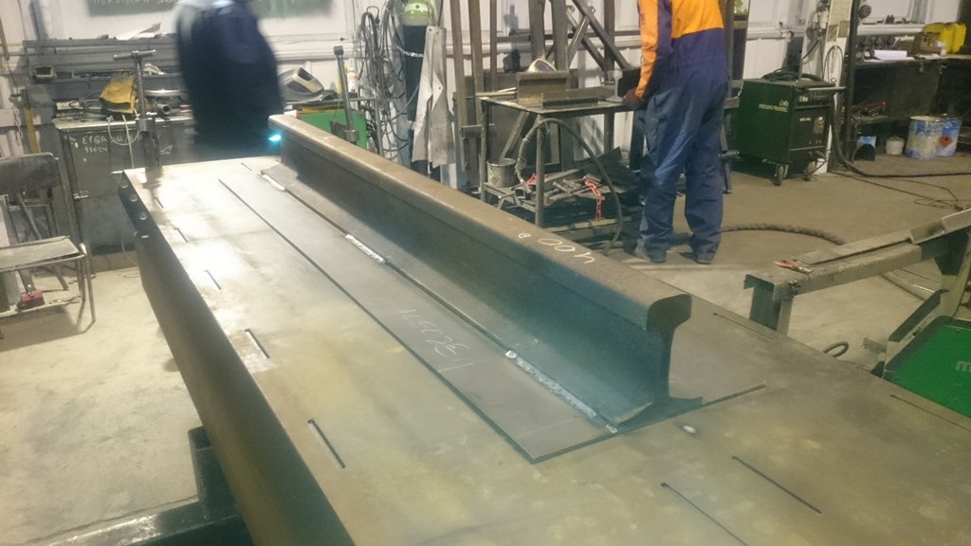
Welding specification: 200mm Welding and step 500mm.
Test specimen lenght 1700mm.
Phase 2. NDT test. Penetration test made in Valga factory. Test coducted by Aleksei, Kristjan and Mihkel.
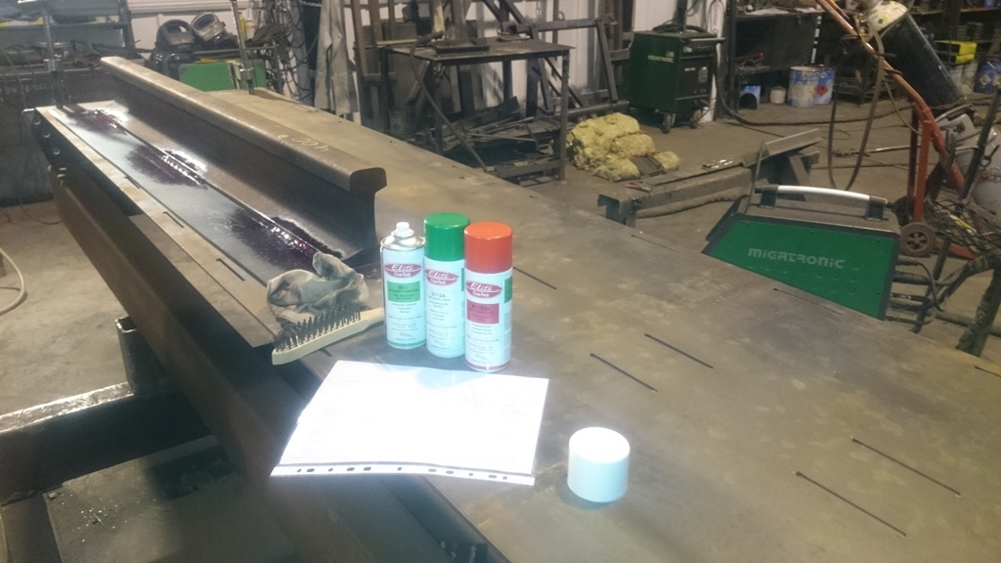
Conclusion: Test showed no impermissible imperfections.
Phase 3. Destructive testing. Cutting with chain saw 200mm long 3 specimens from 1700mm specimens. Two 200mm specimens where cutted from specimen, which was preheated to 400 C degrees, and third specimen from specimen, which was preheated to 200C degrees.
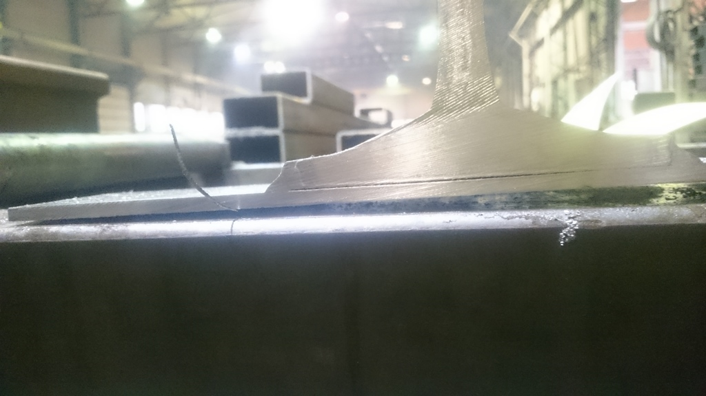
Conclusion: Welding was fully merged with basic materials and no impermissible imperfections where appeared.
Phase 4. Destructive test with press. 200mm specimens where pressed to see, where the breaking point is. 1 specimen was from specimen, which was preheated to 400 C degrees and another was from 200 C degree specimen. 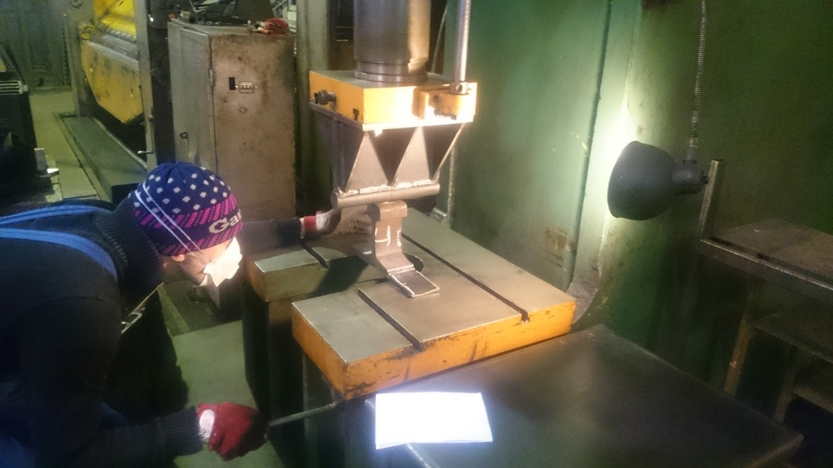
Conlusion: breaking point where from the middle of welding and it was satisfied result. Welding was informaly approved by Tallinn University of Tehcnology professor A. Laansoo
Phase 5. 200mm Specimen where tested by Tallinn University of Tehcnology laboratory. Report included (Annex 1).
Recommendation for future: developing WPS and WPQR

